 | Monday | Tuesday | Wednesday | Thursday | Friday
WEEK 1 | **The following are national holidays.  - Butter Lover’s Day  - Banana Cream Pie  - Cold cuts Day  7- Cereal Day  8- Pancake Day | 1 | 2 | 3 | 4
Breakfast |  | Bagels w/Jelly & Milk | Cereal, Bananas & Milk | French Toast Sticks, Oranges & Milk | Blueberry Oatmeal & Milk
AM Snack |  | Cheese & Crackers | Oranges & Animal Crackers | Carrot Sticks & Ranch | Yogurt & Peaches
LUNCH |  | *Wow! Butter & Jelly Sandwiches, Peaches, Mixed Veggies & Milk | Chicken & Rice Casserole w/Broccoli, Pears & Milk | *Ham & Cheese Sandwiches, Chips, Pickles, Peaches & Milk | Beef Stroganoff, Peas, Pears & Milk
PM Snack |  | Trail Mix & Juice | *Banana Cream Pie & Vanilla Wafers | Cinnamon Apples & Grahams | Animal Crackers & Juice
WEEK 2 | 7 | 8 | 9 | 10 | 11
Breakfast | *Cereal, Bananas & Milk | *Blueberry Pancakes & Milk | Cereal, Bananas & Milk | Cream of Wheat, Oranges  & Milk | Waffles, Bananas & Milk
AM Snack | Animal Crackers & Juice | Oranges & Graham Crackers | Pretzels & Cheese | Cucumbers & Ranch | Celery & Wow! Butter
LUNCH | Teriyaki Chicken, Rice and Broccoli, Pineapple & Milk | Cheesy Chicken Broccoli & Rice Soup, Crackers, Oranges & Milk | *Meatballs, Spaghetti, Salad, Peaches & Milk | Turkey & Cheese Sandwiches, Pretzels, Pickles, Pears & Milk | Chicken Nuggets, Mixed Veggies, Peaches & Milk
PM Snack | Bananas & Vanilla Wafers | Goldfish & Juice | Yogurt & Animal Crackers | Trail Mix & Juice | Ice Cream & Bananas
WEEK 3 | 14 | 15 | 16 | 17 | 18
Breakfast | Biscuits, Jelly & Milk | Breakfast Sandwiches, Oranges & Milk | Cereal, Bananas & Milk | Cinnamon Toast, Oranges & Milk | Blueberry Oatmeal & Milk
AM Snack | Strawberry Yogurt & Graham Crackers | Pretzels & Mixed Fruit | Ham & Cheese Cracker Sandwiches | Animal Crackers & Juice | Goldfish & Applesauce
LUNCH | Hamburgers, *Chips, Pickles, Pears & Milk | Hamburger Tater Tot Casserole w/Veggies, Oranges & Milk | Chicken Noodle Soup w/Veggies, Crackers, Peaches & Milk | *Corned Beef, Rolls, Pears, Green Beans & Milk | *Sloppy Joes, Chips, Pickles, Pineapple & Milk
PM Snack | Goldfish & Juice | Rice Krispie Treats & Milk | Jello w/Fruit | Bananas & Vanilla Wafers | Oranges & Pretzels
WEEK 4 | 21 | 22 | 23 | 24 | 25
Breakfast | French Toast Sticks, Bananas & Milk | English Muffins w/Jelly & Milk | Cereal, Bananas & Milk | Cream of Wheat, Oranges & Milk | Closed
AM Snack | Trail Mix & Juice | Apples & Cheese | Graham Crackers & Juice | Carrot Sticks & Ranch | For
LUNCH | Mini Pizzas, Salad, Pears & Milk | Frito Pie, Corn, Pineapple & Milk | Chicken Tomato Soup w/Rice, Crackers, Oranges & Milk | Cheesy Scalloped Potatoes w/Chicken, Peas, Pears & Milk | Good
PM Snack | Strawberry Yogurt & Animal Crackers | Chocolate Pudding & Pretzels | *Chips & French Onion Dip | Cinnamon Apples & Animal Crackers | Friday!!
WEEK 5 | 28 | 29 | 30 | 31 | 9- Meatball Day  14 - Potato Chip Day  17 - Corned Beef Day  18 - Sloppy Joe Day  23- Chips & Dip Day  31- Tater Day
Breakfast | Waffles, Bananas & Milk | Cinnamon Toast, Oranges & Milk | Cereal, Bananas & Milk | Bagels w/Jelly & Milk
AM Snack | Tortillas & Cheese | Oranges & Pretzels | Crackers & Cheese | Yogurt & Blueberries
LUNCH | Beef Stew w/Veggies, Bread, Pears & Milk | Chicken Alfredo, Peas, Peaches & Milk | Quesadillas, Baked Beans, Pineapple & Milk | Chicken Patties, *Mashed Potatoes, Gravy, Peaches & Milk
PM Snack | Applesauce & Grahams | Bananas & Animal Crackers | Cornbread & Jelly | Ambrosia Salad & Crackers
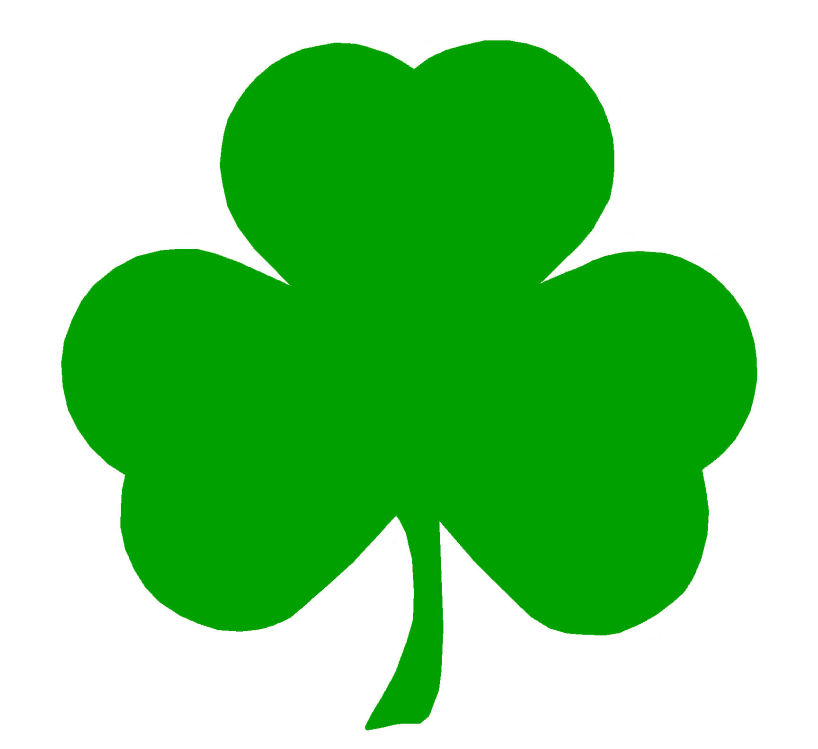Covenant Schools of Rio Rancho March 2016 Menu

